

A Project Report on

PRODUCT DEVELOPMENT AND SALES



THEME: GO GREEN GO HEALTHY

SUBMITTED TO: PROF SATYA SIDHARTHA PANDA

BY

ANITA SAH AND NAGAVARAPU JHANSI

PGDM 22-24 BATCH

PATEL INSTITUTE OF MANAGEMENT STUDIES

BANGALORE

CONTENT

* Introduction
* Team
* Product and pricing
* Ideation and Process
* Marketing
* Sales
* Feedback
* Learning
* Introduction:

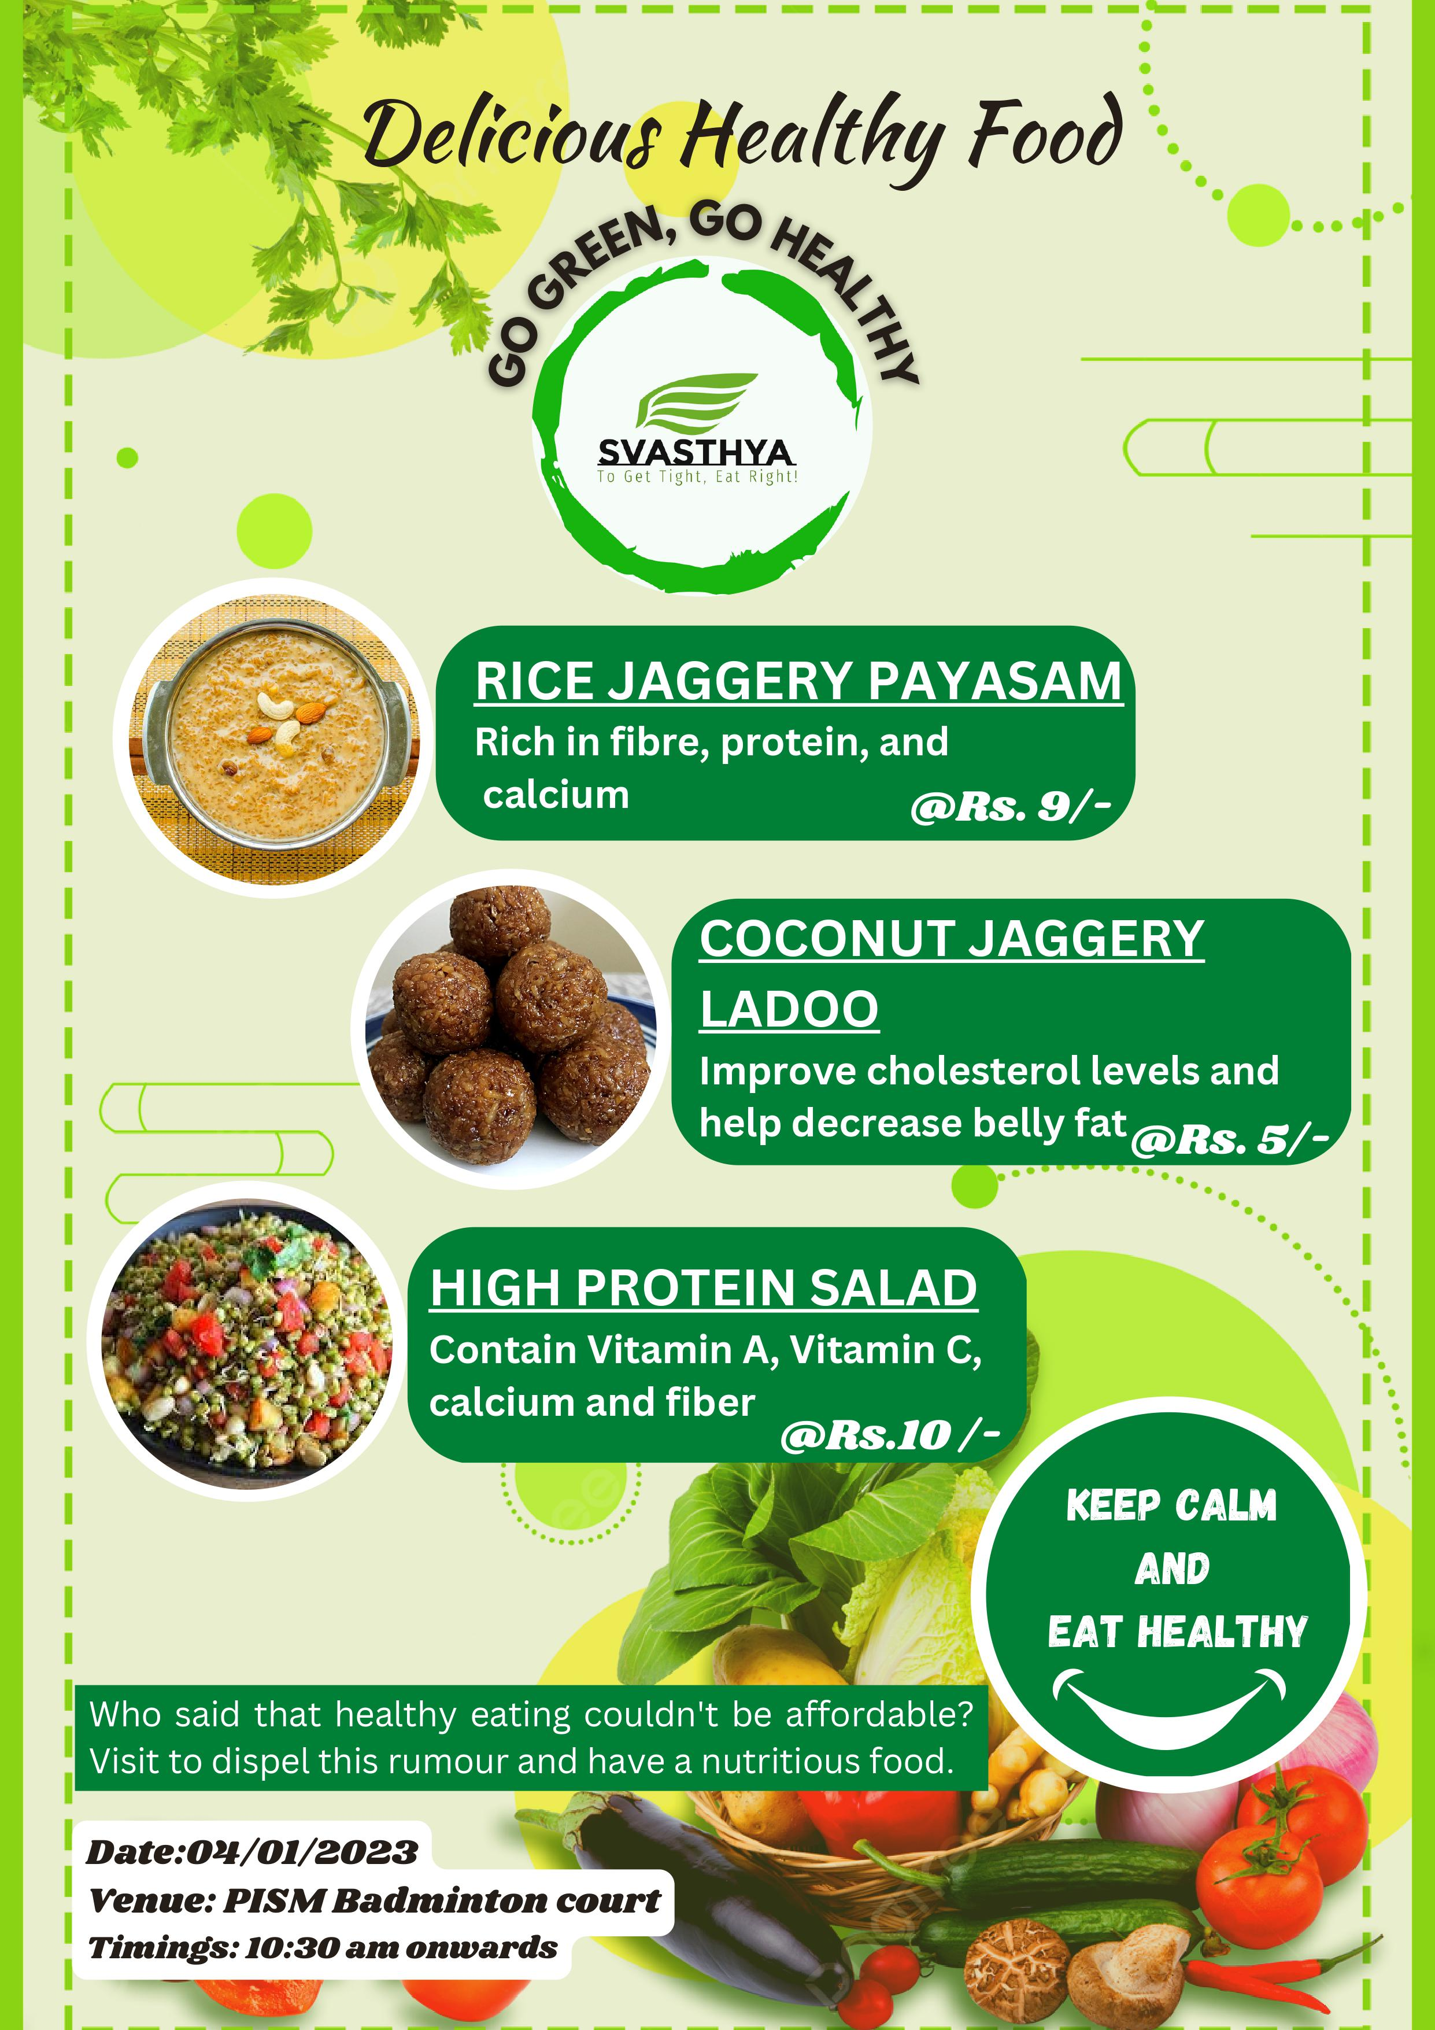

**Theme: Go green, go healthy**

Why Svasthya?

* The Sanskrit word for health, svasthya, represents the innate wisdom of being (stha) loyal to oneself (sva).
* Our logo's green colour stands for "Go Green," and Svasthya is a representation of the "Go Healthy" idea.



Picture: Logo

* Team



Hi!

I am Anita Sah. I am from Assam.

I am pursuing PGDM at PIMS campus in Bangalore.

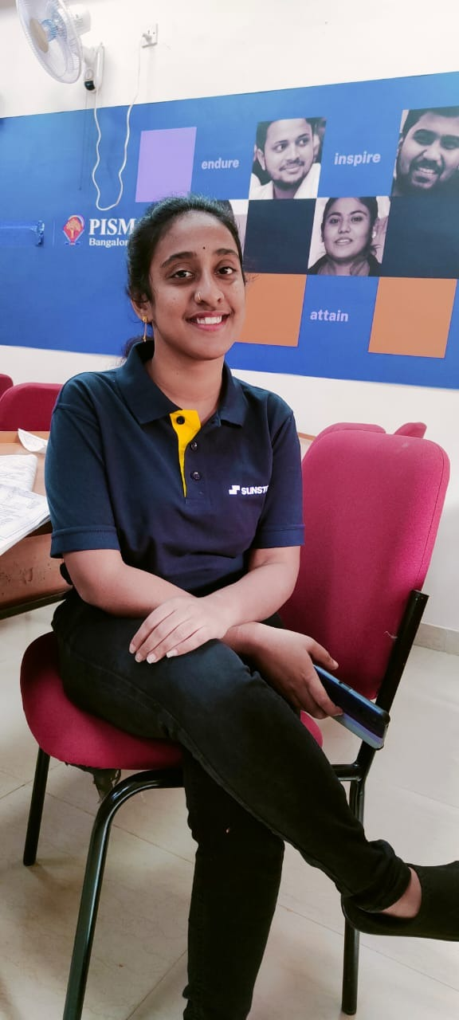

Hi!

I am Nagavarapu Jhansi. I am from Andhra Pradesh.

I am pursuing PGDM at PIMS campus in Bangalore.

* Product and pricing

Products were developed with an Rs 400 price range in mind. We have produced a total of 3 unique products. Every product has a price of less than Rs 20 as stated. These are listed below.

1. Rice jaggery payasam- Rs 9/-

2. Coconut jaggery ladoo- Rs 5/-

3. High protein salad - Rs 10

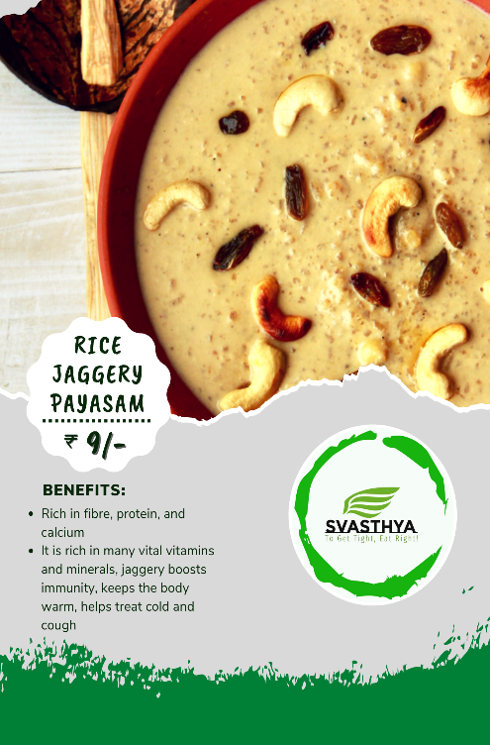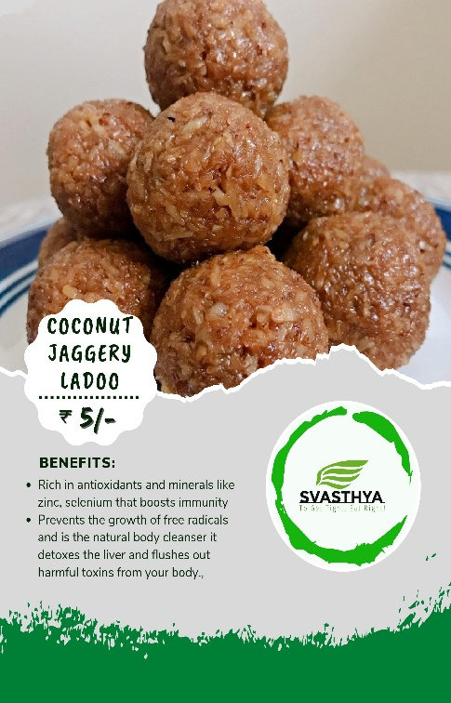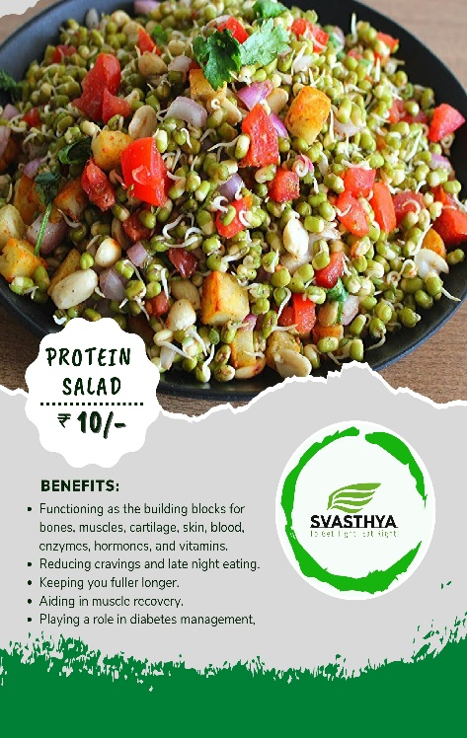

**Rice Jaggery Payasam Coconut Jaggery Ladoo High Protein Salad**

Ingredients used: Ingredients used: Ingredients used

1. Rice 1. Coconut 1. Brown gram

2. Jaggery 2. Jaggery 2. Mung bean

3. Milk 3. Carrot, cucumber,

4. Dry fruits beetroot, pomegranate,

Lemon, mint leaves,

Corn, parsley

* Ideation and Process

Rice jaggery payasam

Step 2: Wash it

Step 1: Take some rice

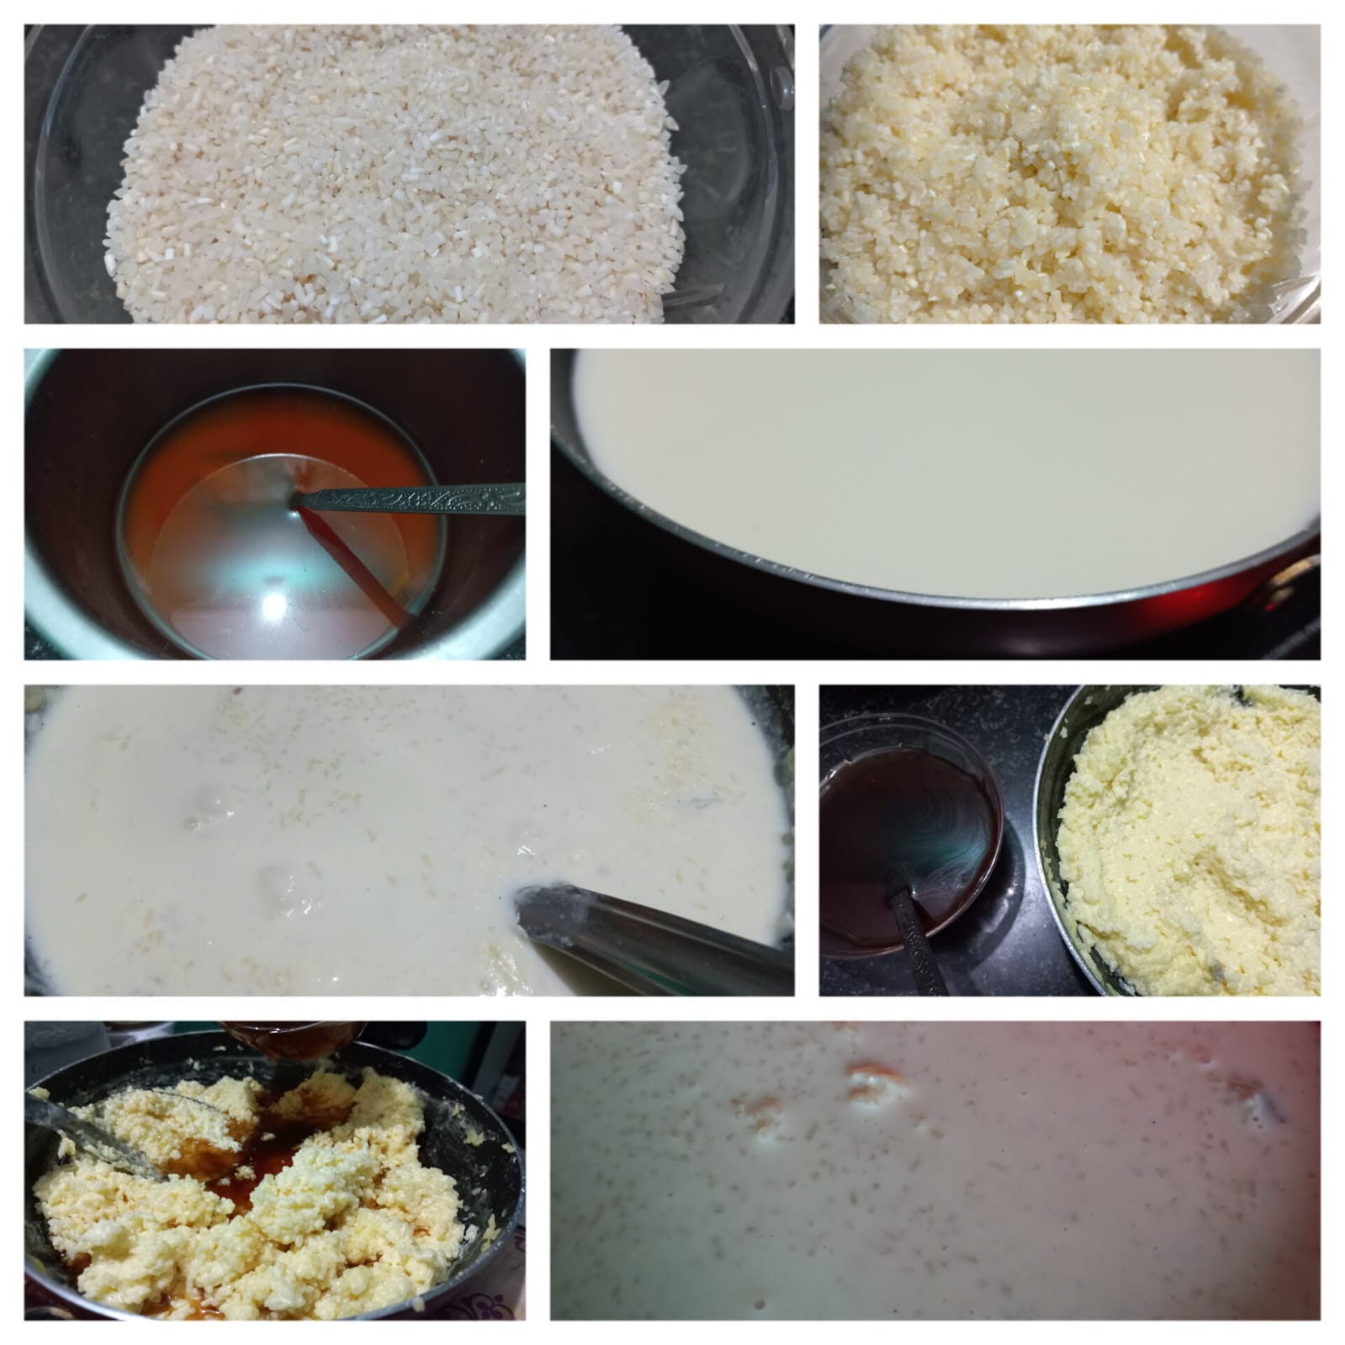

Step 8: Add dryfruits and serve

Step 7: Mix jaggery syrup and mix it

Step 6: Let them **cool down**

Step 5: Cook rice and milk

Step 4: Boil milk

Step 3: Make jaggery syrup

Coconut jaggery ladoo

Step 2: Make jaggery syrup

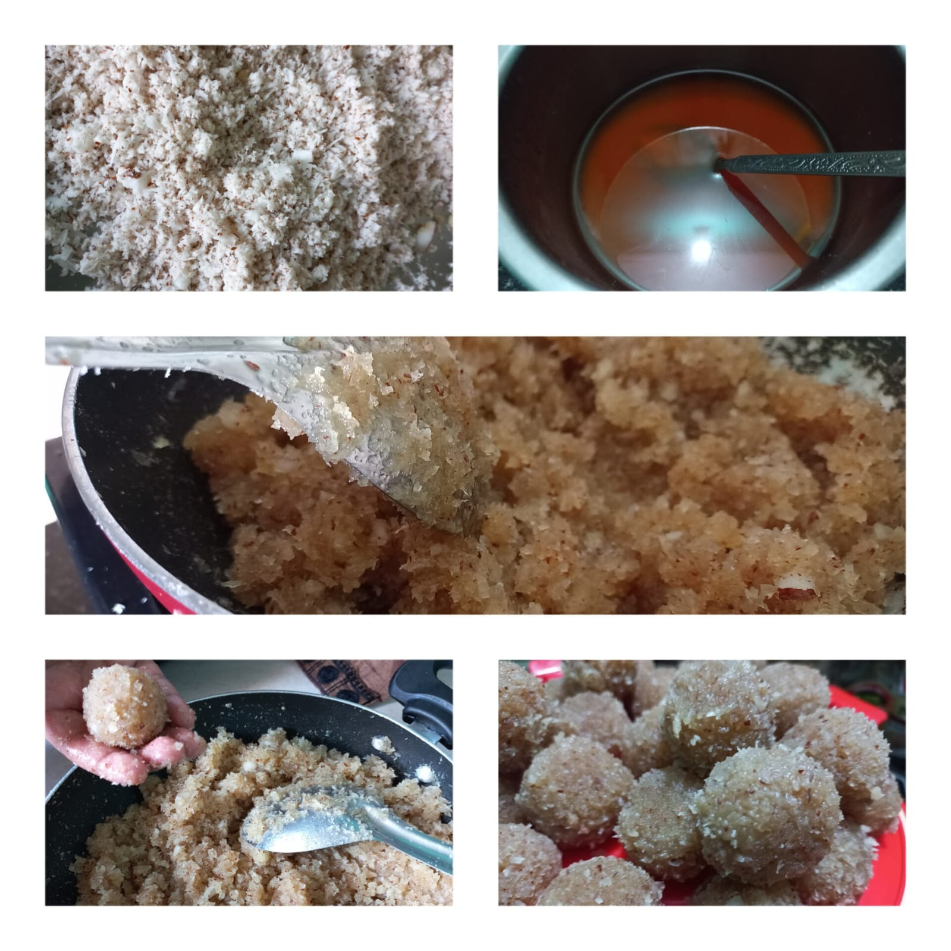

Step 3: Mix jaggery syrup to coconut powder and cook it

Step 1: Grind fresh coconut

Step 5: Make small ladoo

Step 4: Let it cool down a little

High Protein Salad

Step 3:Boil it

Step 1: Soak chana and mung

Step 2: Let it sprout

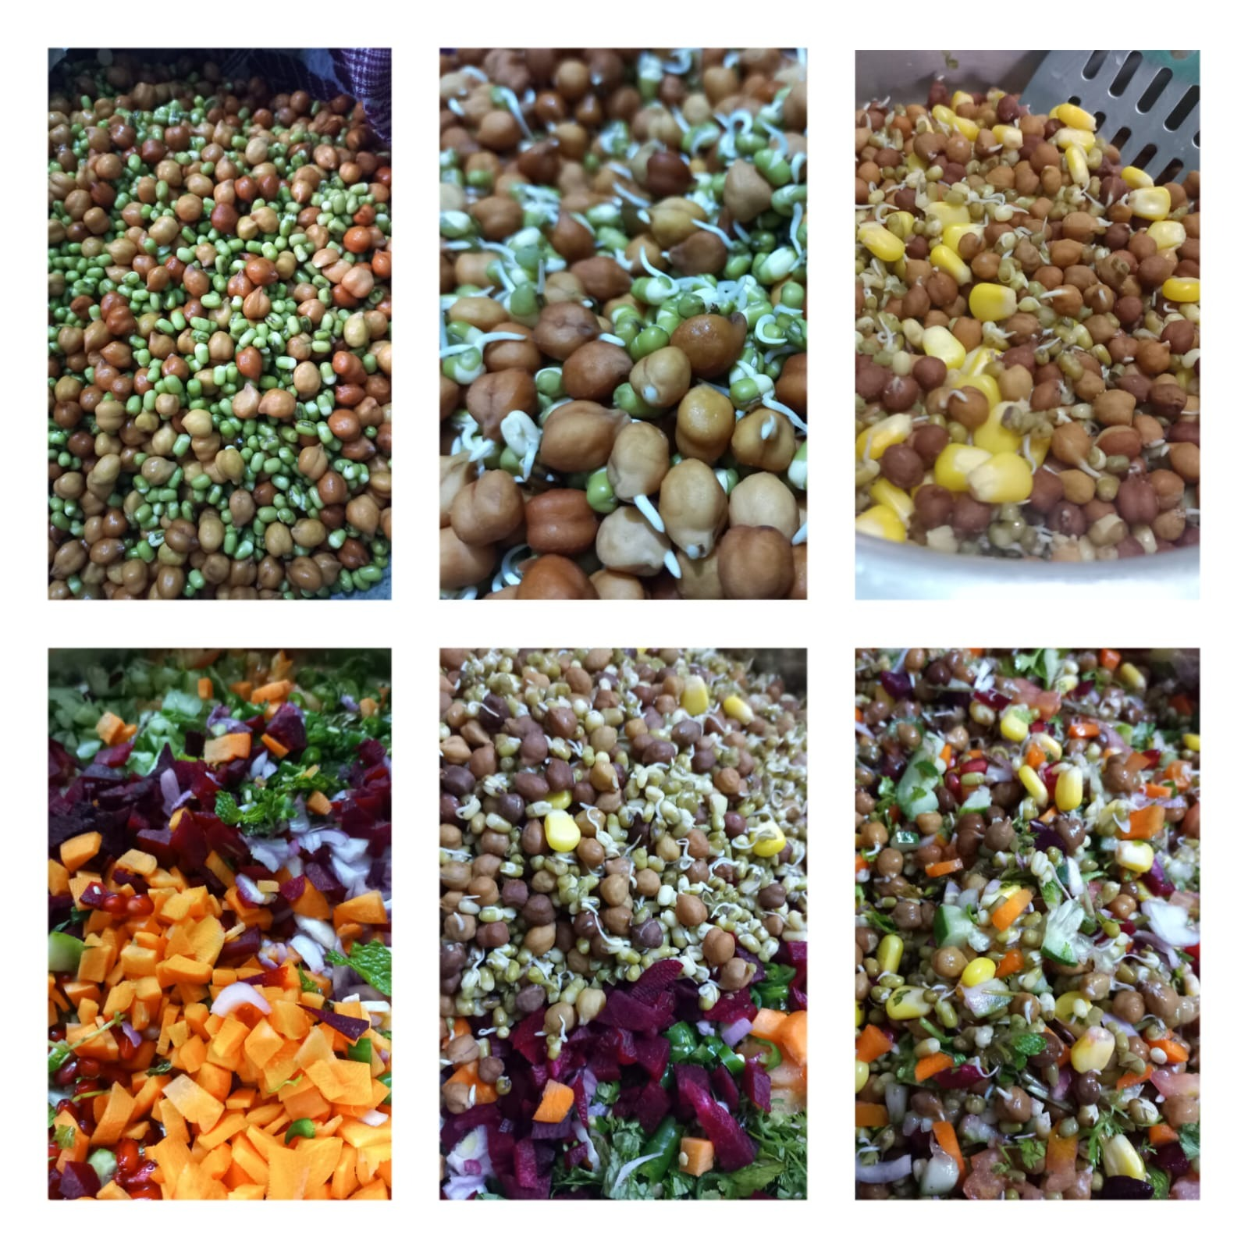

Step 6: Add some salt, pepper, lemon juice and enjoy!

Step 5: Mix it with boiled mixture

Step 4: Cut all veggies

* Marketing

1. We went and explained everything to the faculty and staffs of our college. We extend an invitation to visit our stall.

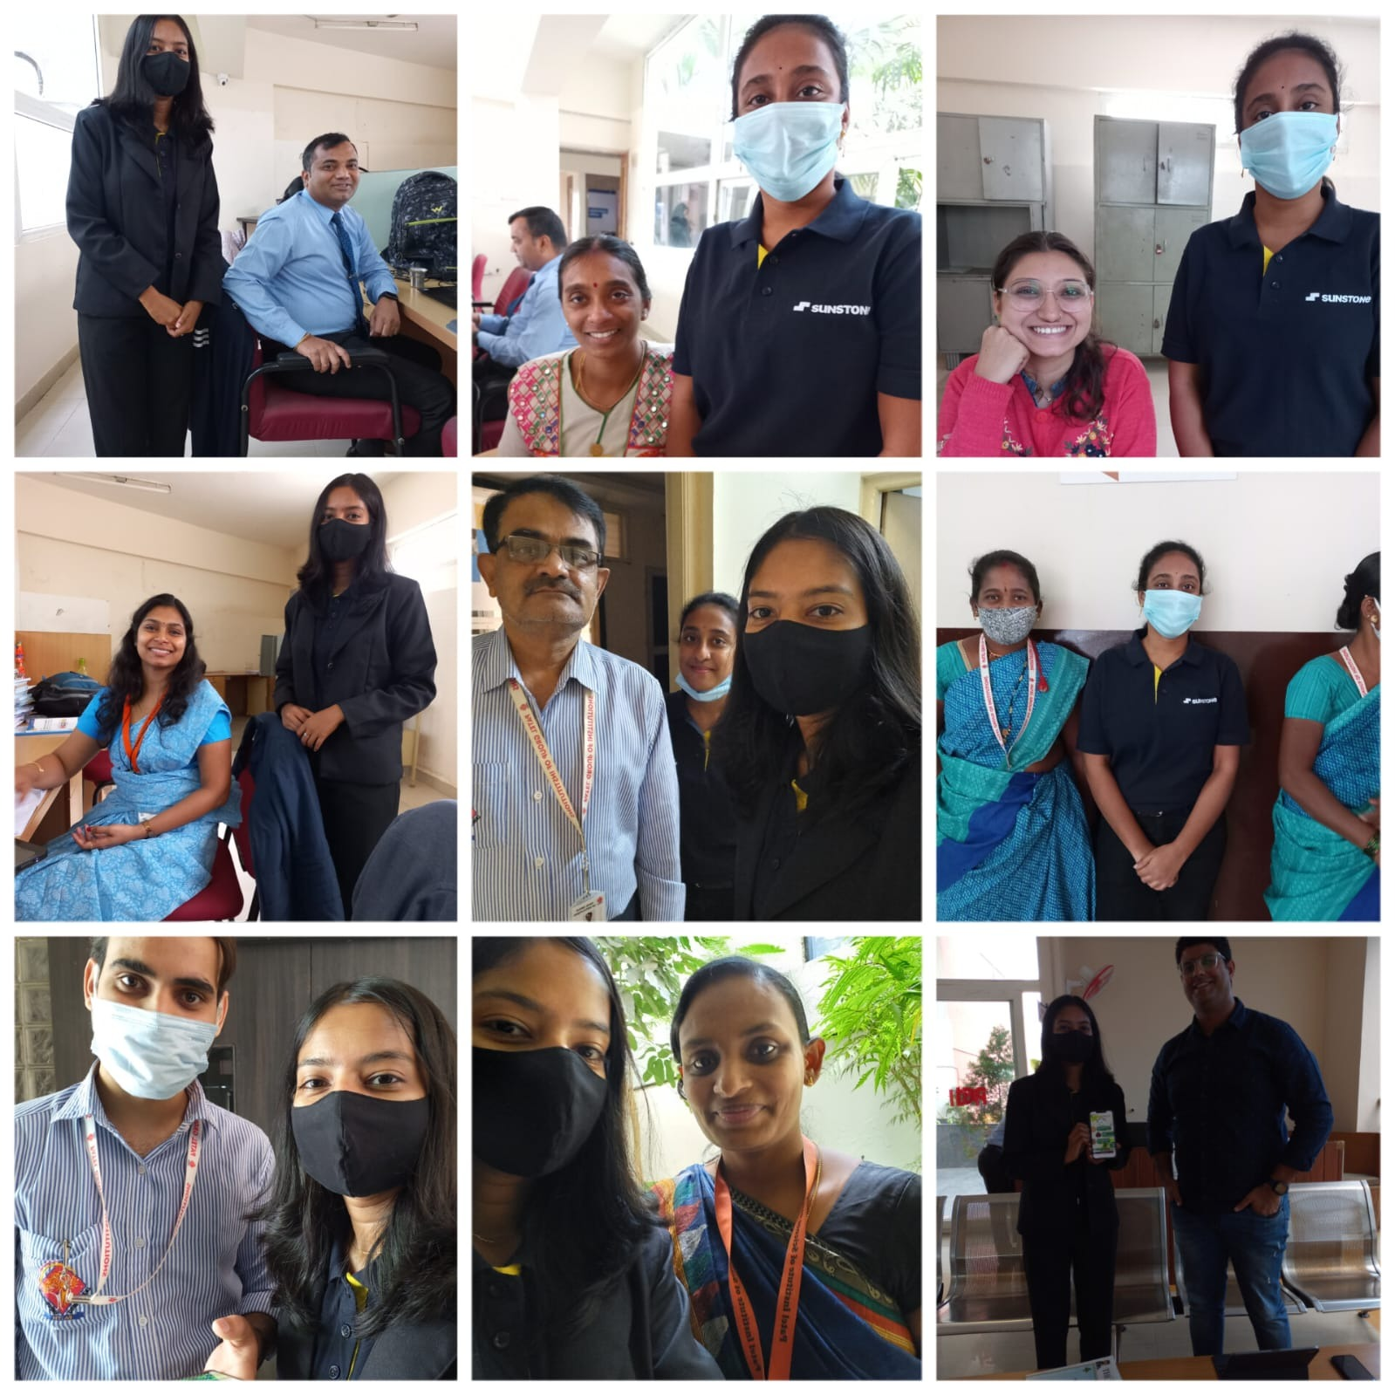 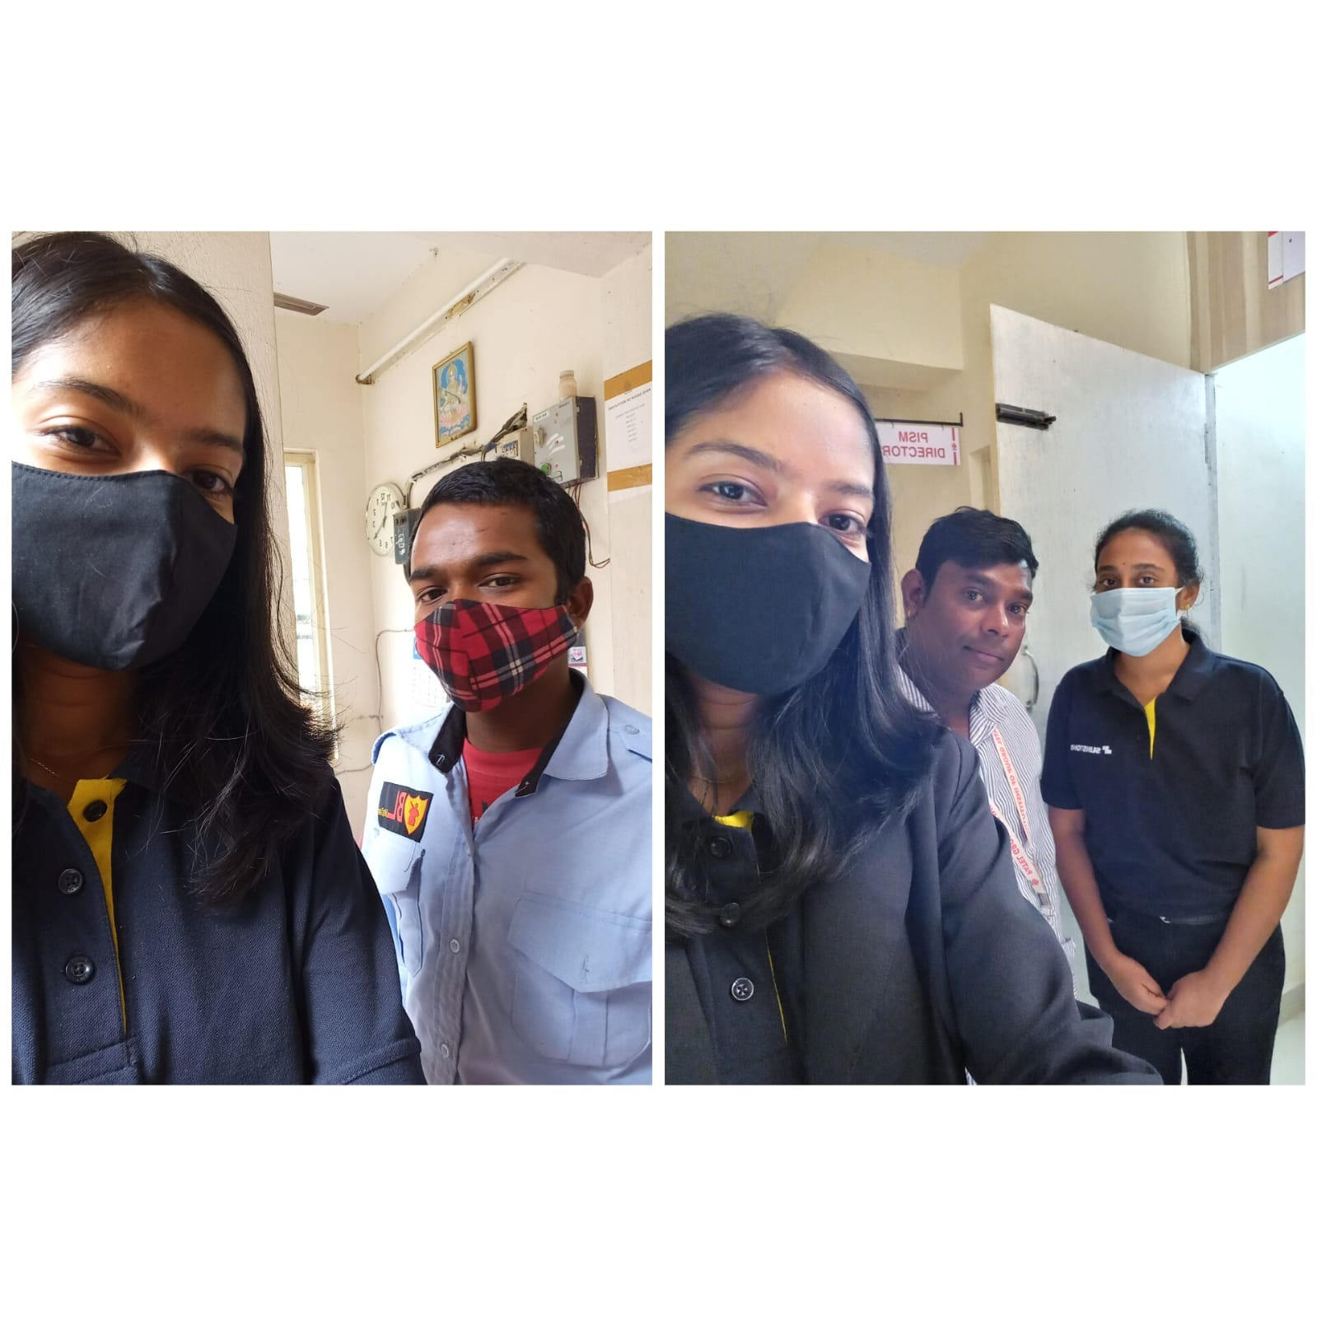

2. To spread the word about our product, we have created posters and adhered our brand to a leaf bowl. To serve, we utilized banana leaves and leaf bowls. The leaf of a guava has been used as a spoon.

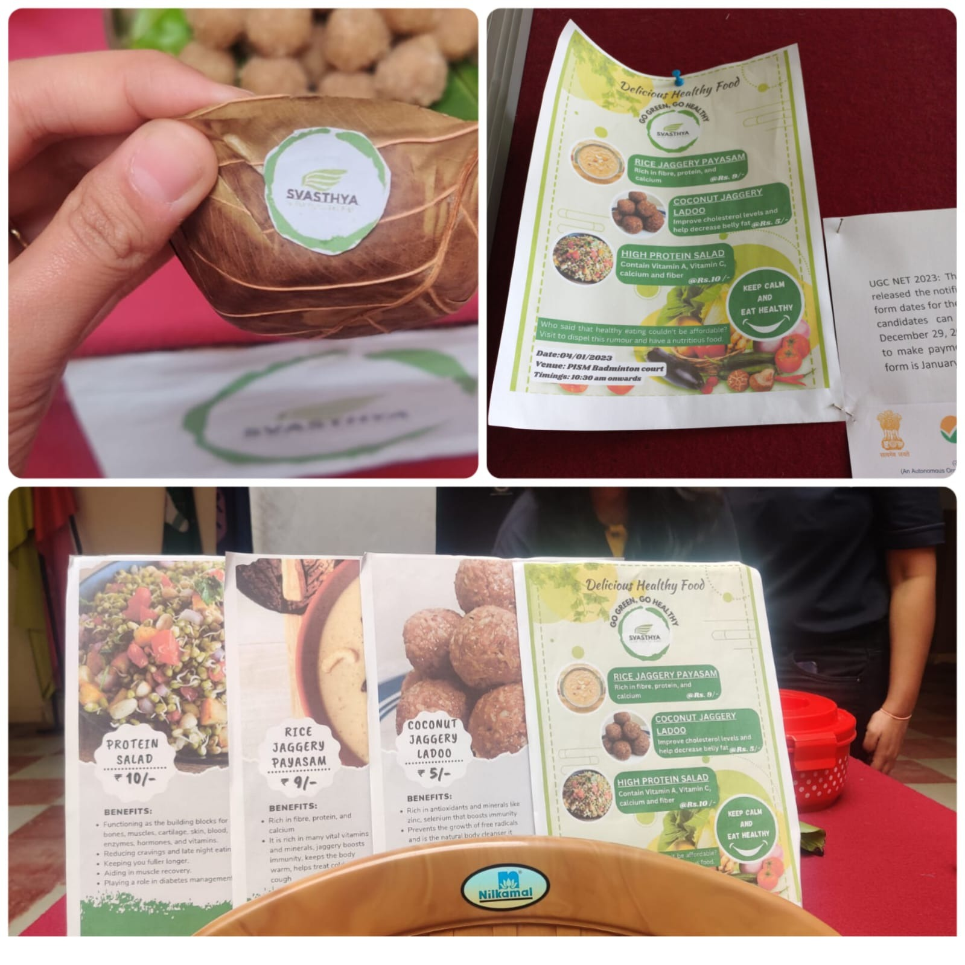

**Using technology:**

To view the menu and provide comments on the item they have taken, we have developed a link and a QR code.

Link: [Svasthya](https://sites.google.com/sunstone.edu.in/svasthya/home) (Please press CTRL + Click on the link to open the website)

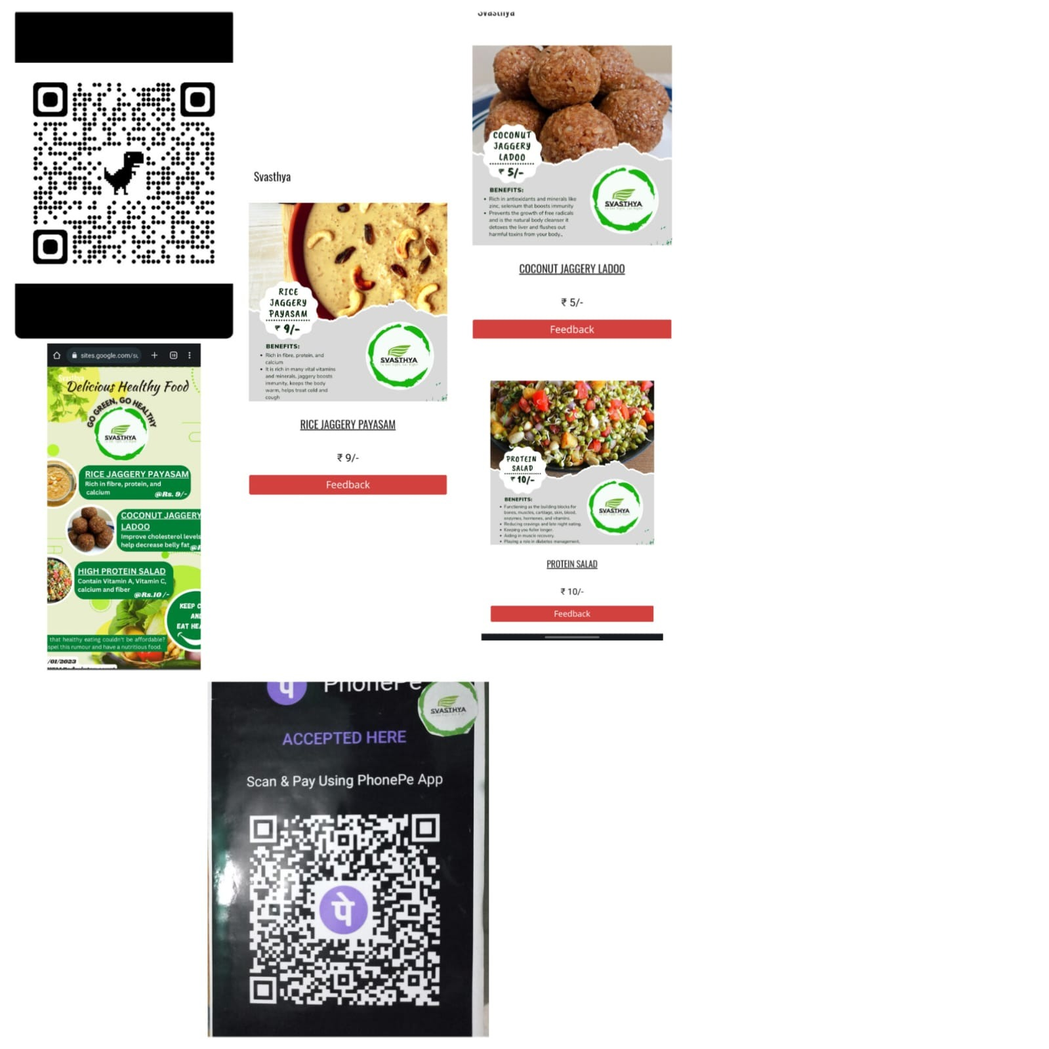

* Sales

Total expenditure v/s total sales

*We have spent Rs 360 on materials. The initial bill was discounted by Rs 14. The overall cost is Rs 360.

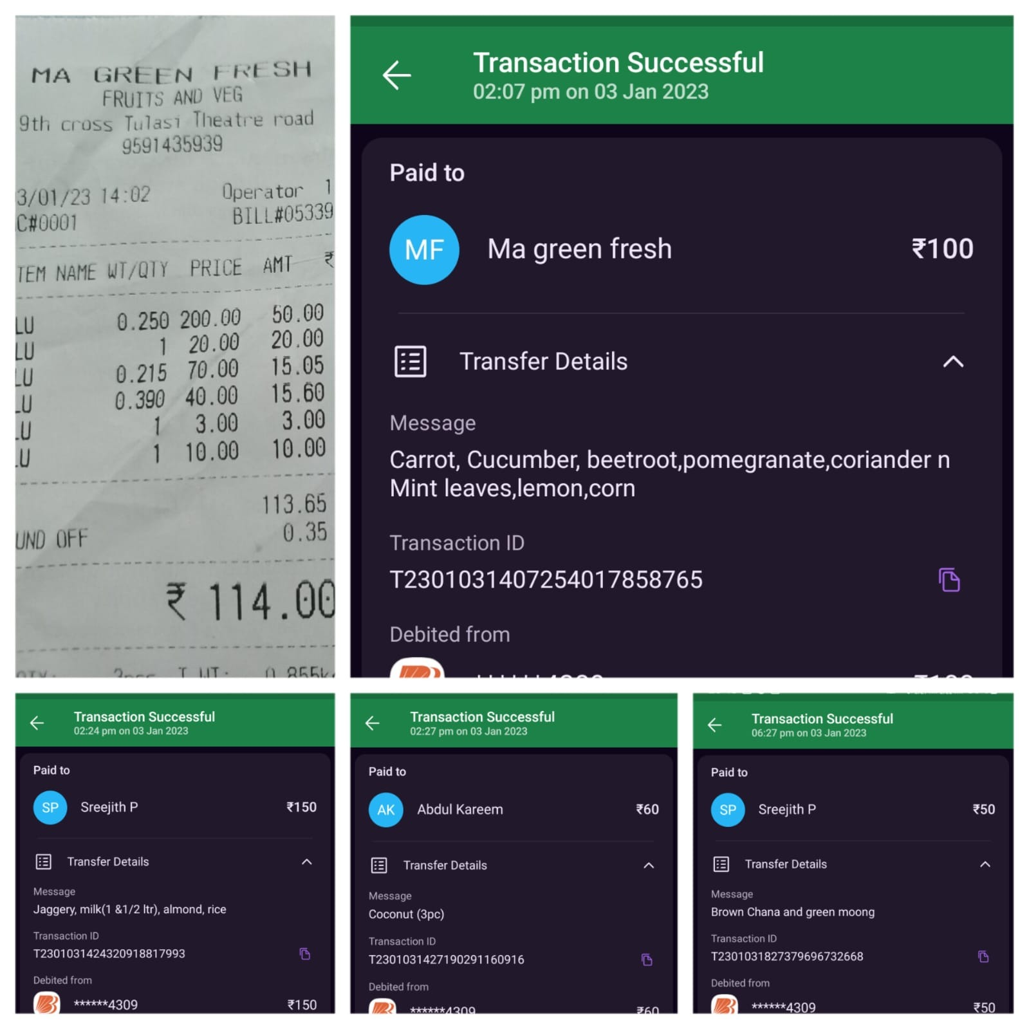

* Through a digital payment method, we received a total of Rs 501.

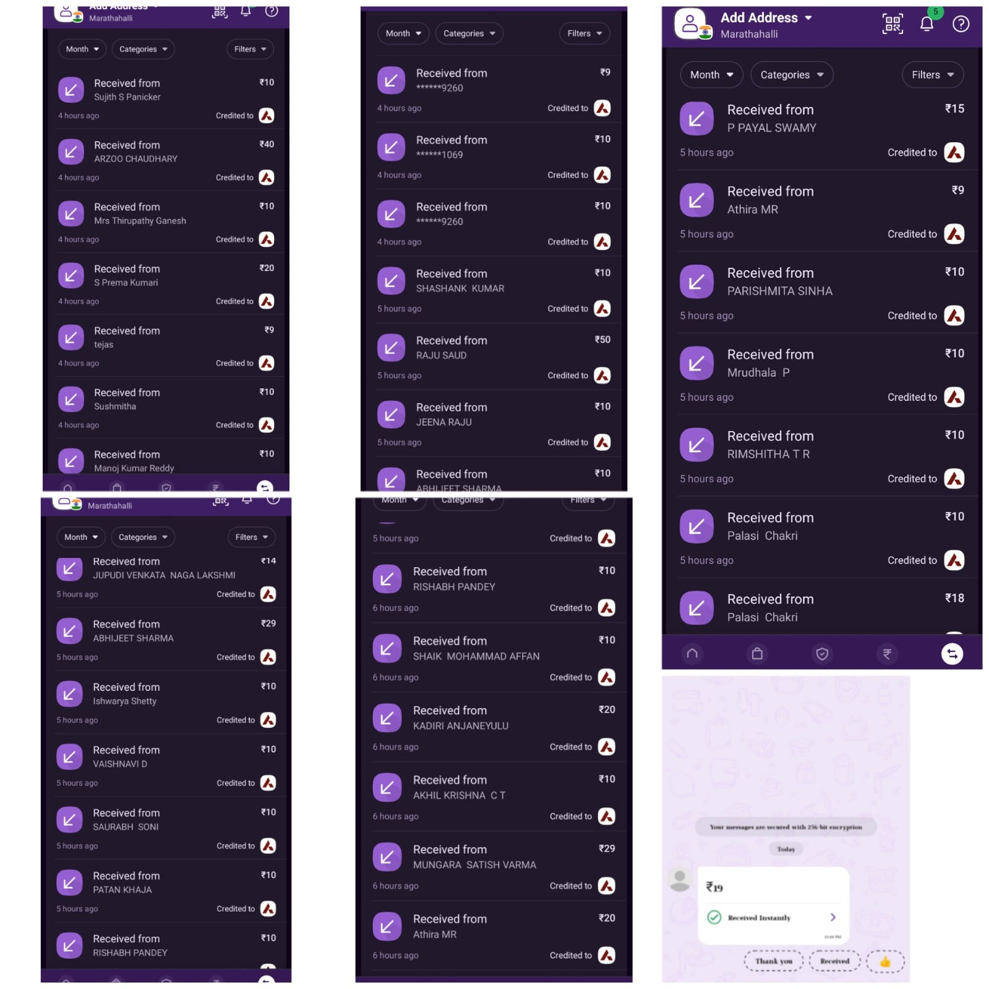

**Cash payment:**

We received a total of Rs 434 in cash since PUC students lacked a cell phone to use UPI.

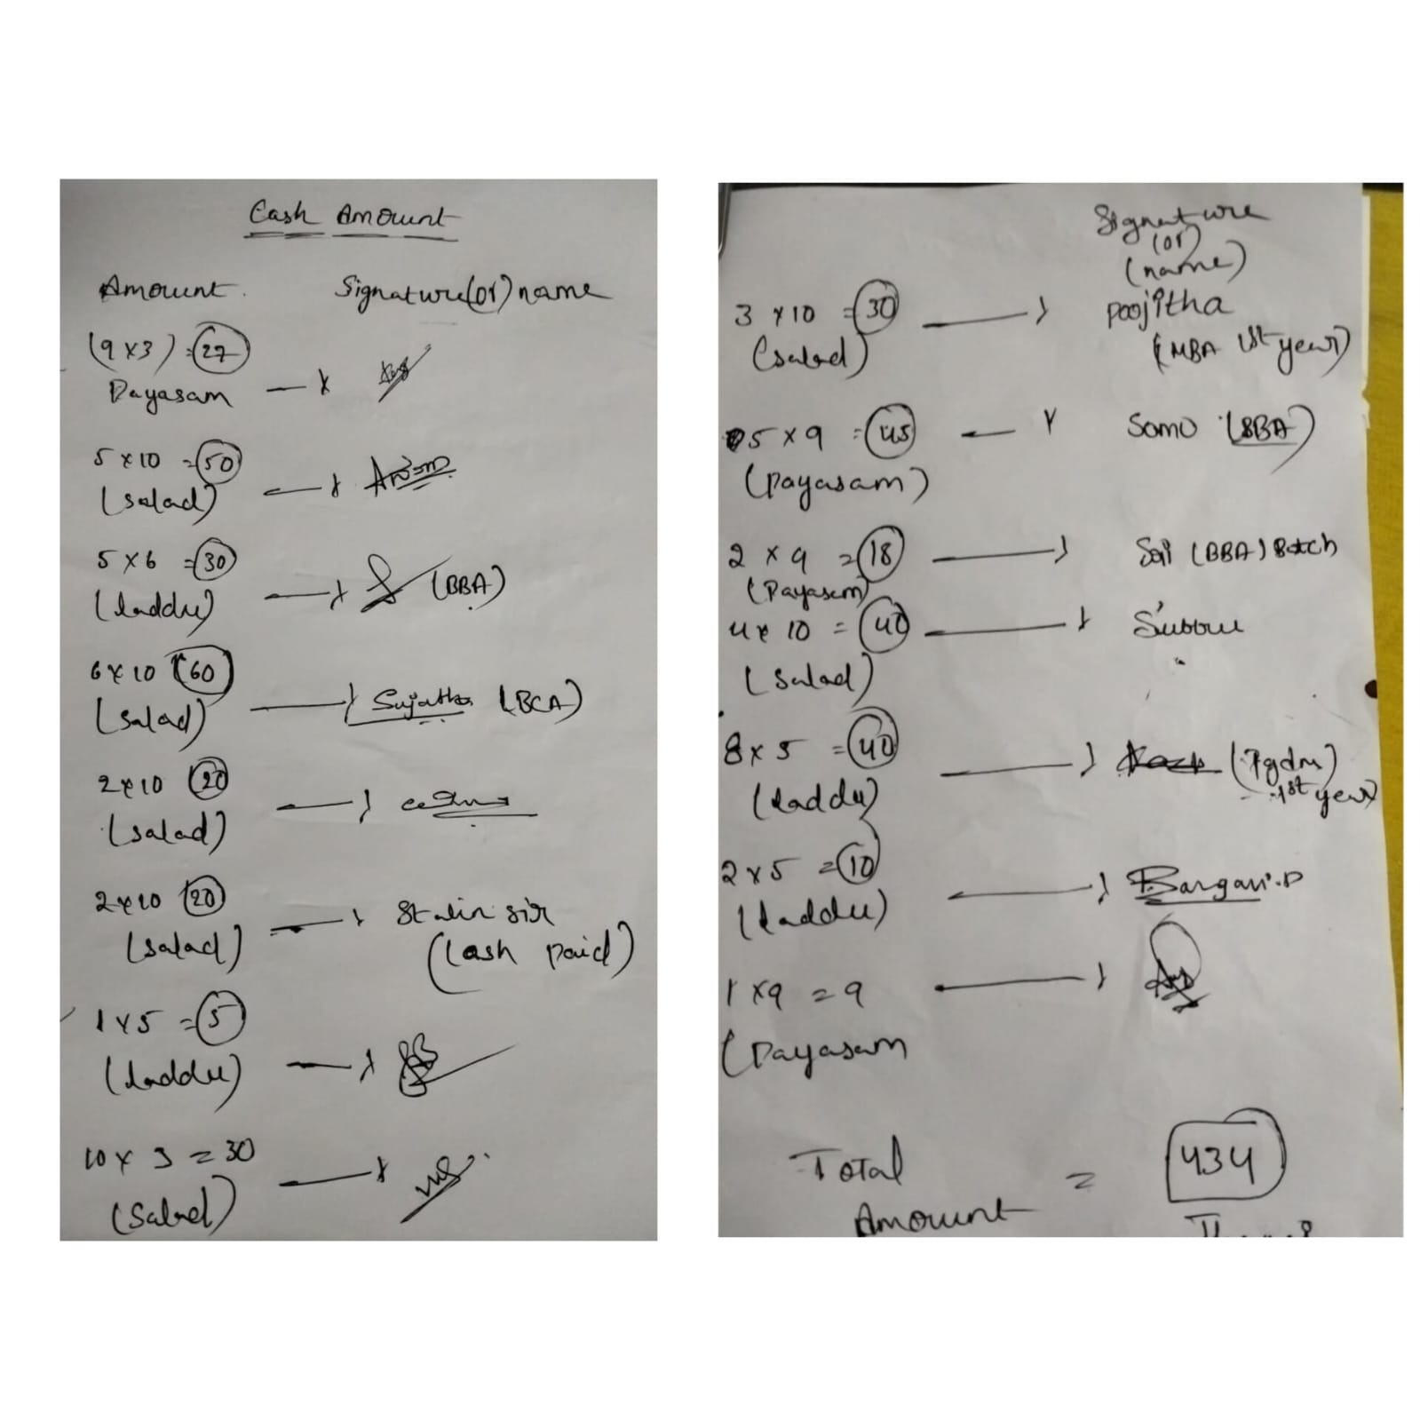

* Feedback

Many of them provided feedback while using our website. Some comments come in video form.

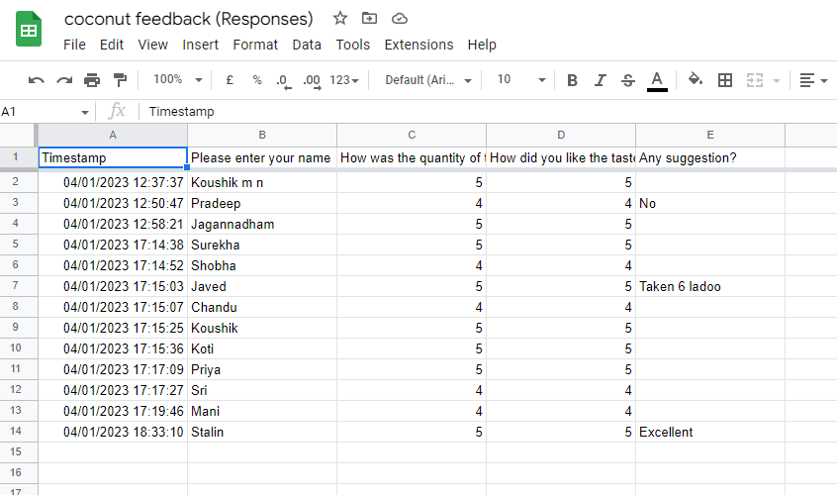 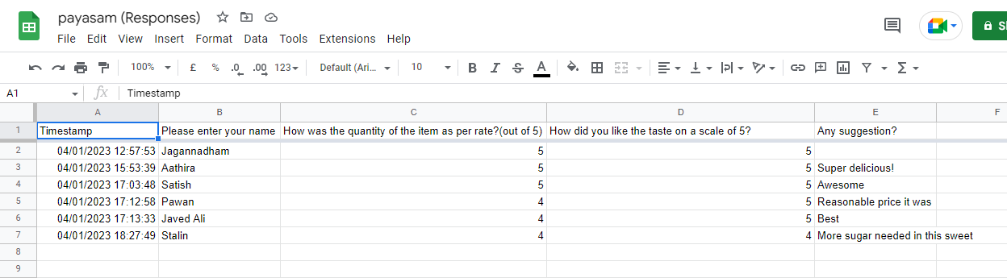 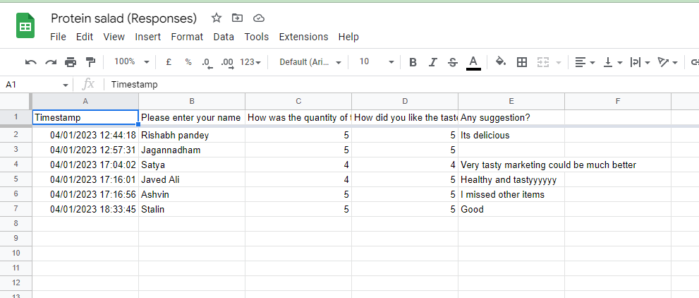

Customer happiness and the smiling face after they eat your food are highly vital for a business.

Here are a few images of satisfied clients who have returned time and time again.

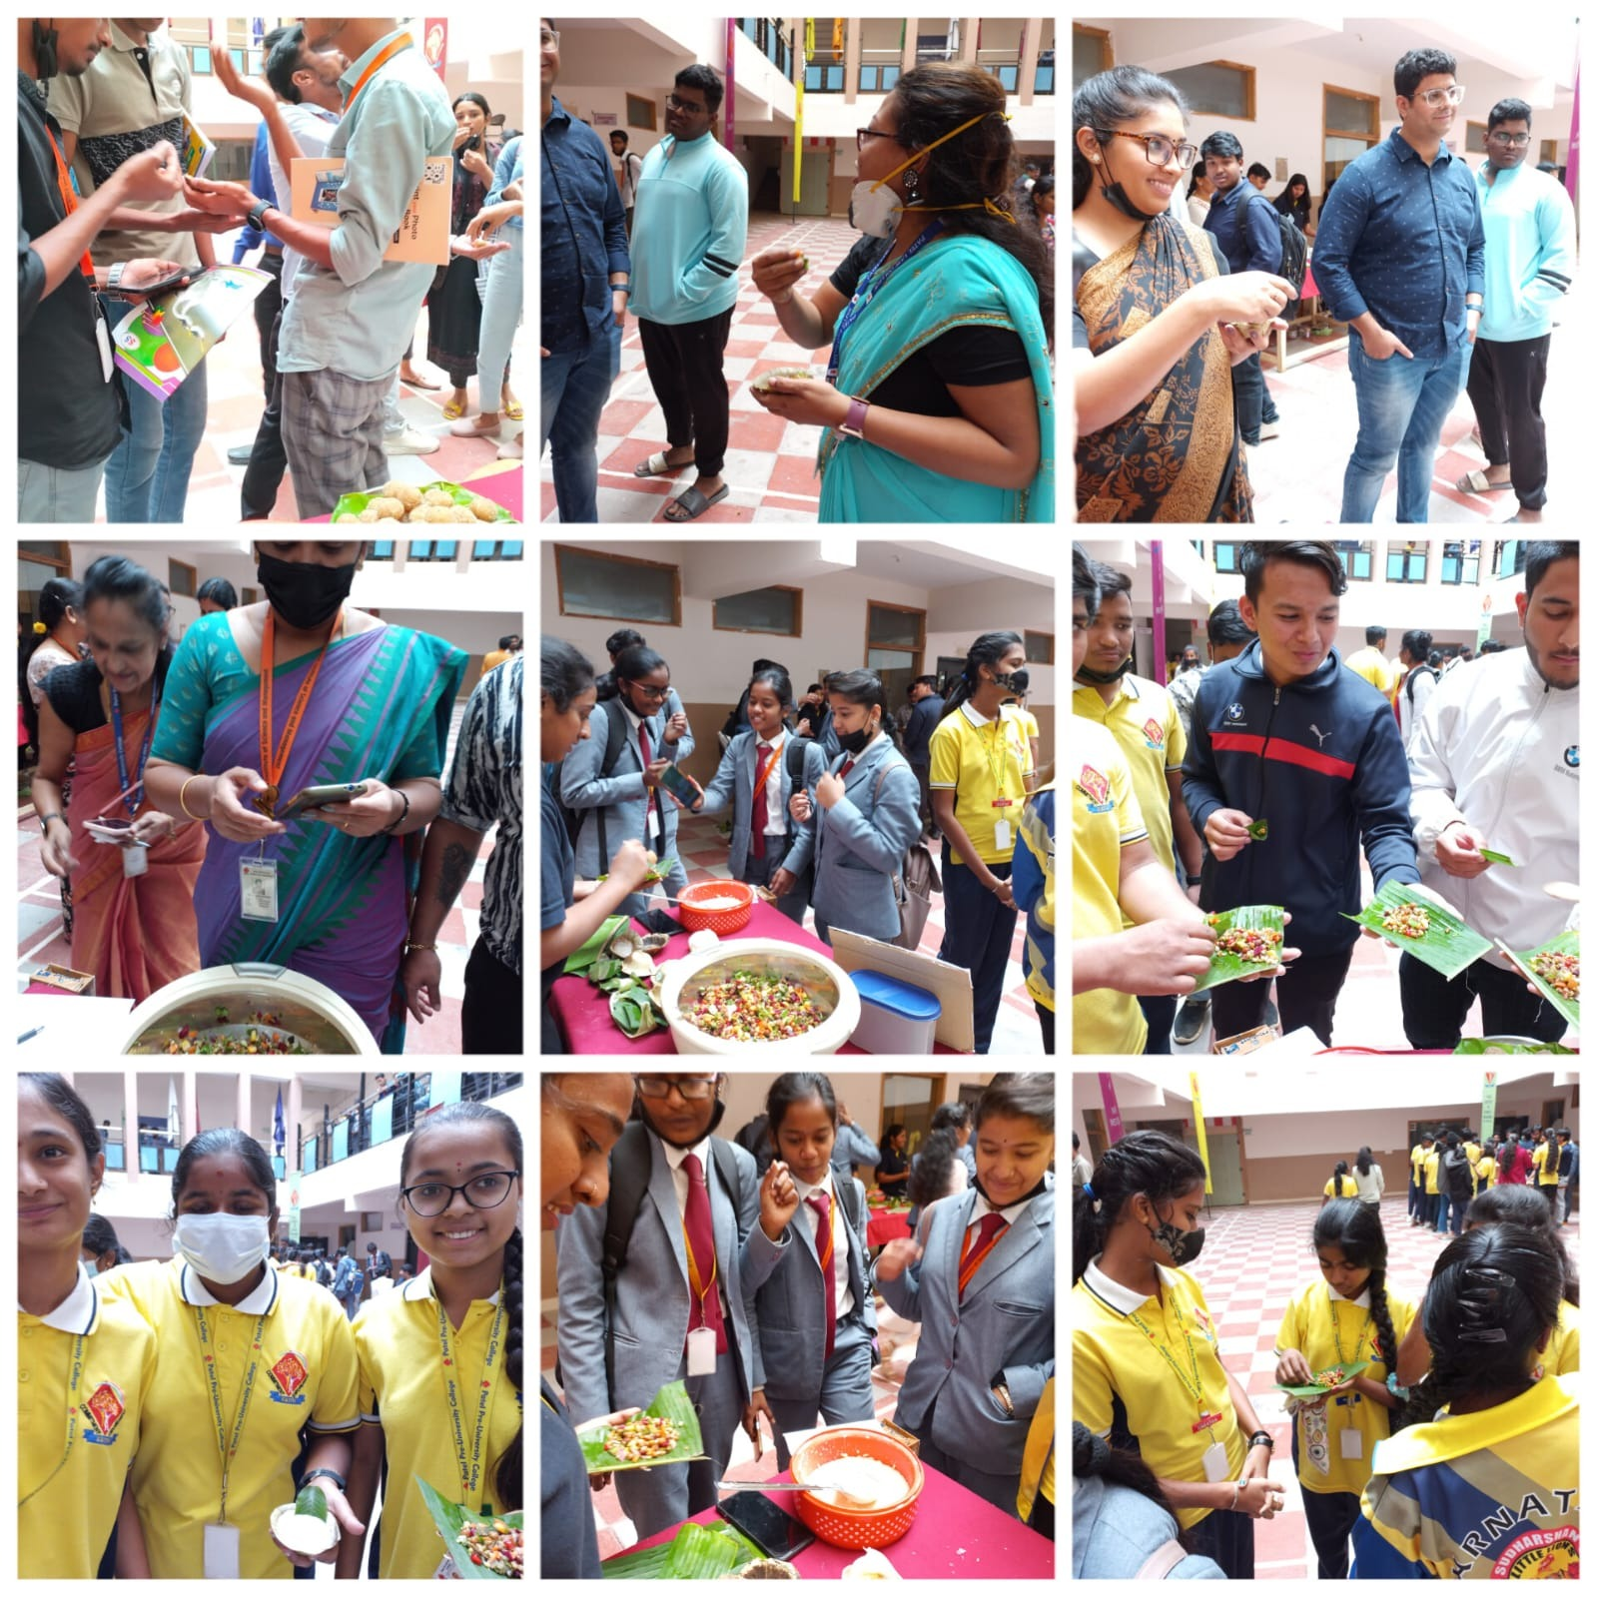

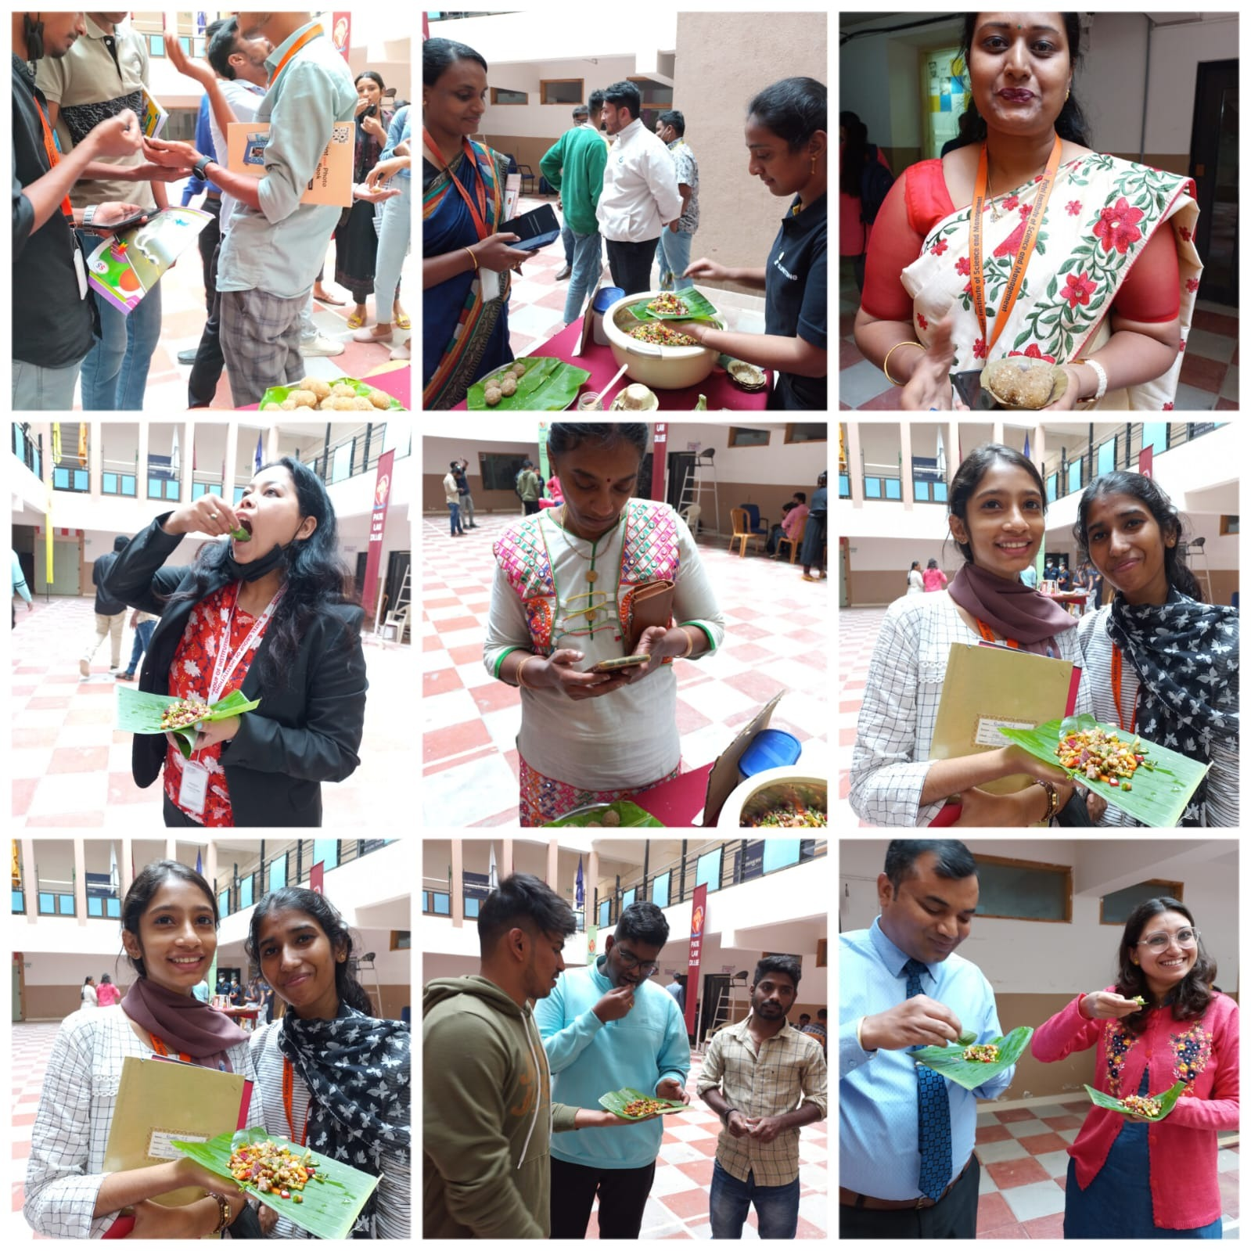

* Learning

This task gave me insight into a variety of topics, including:

1. How to launch a business?

2. How to attract more clients?

3. Creating a unique product

4. How to manage crowds?

5. How to trust your partner?

6. becoming more presentable

7. Market your goods to affluent, large audiences

8. How to obtain more orders?

- Nagavarapu Jhansi

Thank you!

I have learned a lot from this activity, including:

1. How to work in a group?

2. How can I make a product on a tight budget?

3. Pricing strategies for large crowds

4. How to encourage the use of technology

5. Gaining a customer's trust requires satisfying them

6. Using organic products to safeguard the environment

7. Getting input and enhancing

8. When developing and marketing your products, keep human and environmental health in mind.

- Anita Sah